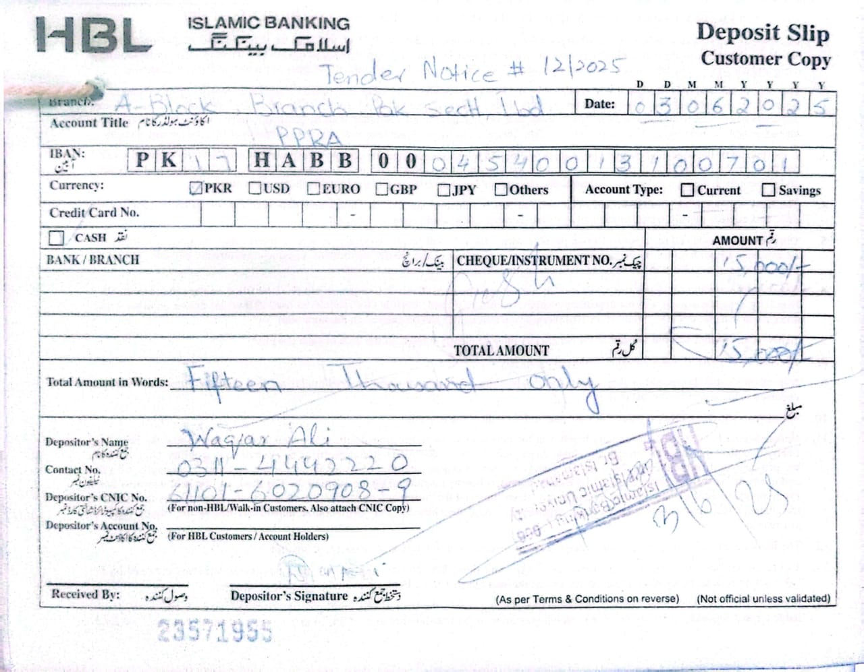
TENDER NOTICE NO.12/2025

TENDER NOTICE FOR PREPARATION / SUPPLY / INSTALATION OF SIGN BOARDS AS WELL AS INSTALLATION OF DIFFERENT ROAD SIGNS AT PUBLIC SECTOR GENERAL HOSPITAL, ISLAMABAD THROUGH OPEN TENDER

A Public-Sector Hospital invites sealed tenders from eligible / reputed firms / suppliers registered with Income Tax / General Sale Tax Department for preparation / supply / installation of sign boards as well as installation of different road signs at Public Sector General Hospital, Islamabad under Single Stage – Two Envelopes Bidding Procedure on FOR Islamabad basis.
Sr. # | Tender No. | Description | Tender Fee | Last Date / Time of Bid submission | Bids Opening Date / Time
1. | 12/2025 | Preparation / Supply / Installation of Sign Boards as well as Installation of Different Road Signs at Public Sector General Hospital, Islamabad | 2,000/- | 24-06-2025  At 10:00 Hrs | 24-06-2025  At 10:30 Hrs

- A set of tender documents along with terms and conditions can be downloaded from PPRA website: www.ppra.org.pk at a cost of Rs. 2,000/- payable in the shape of “Pay Order / Demand Draft” in favor of “Sr. Accounts Officer, Public Sector General Hospital, Islamabad”. The Pay Order / Demand Draft and tender request must be submitted along with tender proposals before closing date of tender. No Tender / Proposal will be accepted without Tender Fee.

- This tender can be seen on PPRA website www.ppra.org.pk also.

- The Competent Authority reserves the right to reject any or all the tenders.

Admin Officer
Public Sector General Hospital
H-11/4 Islamabad
Ph: 051-9257171
Ext: - 289
INSTRUCTIONS

TO FILL UP THE TENDER DOCUMENTS
Technical worksheet

- Download file from URL: www.ppra.org.pk named “Tender File preparation / supply / installation of sign boards as well as installation of different road signs at Public Sector General Hospital, Islamabad” for quoting technical specification”.
- Open relevant file.
- Please write “NQ” against non-quoted items in empty cells.
- Technical Proposal should not indicate any price. There will be two different files; one for Technical Proposal only and one for Financial Proposal. All pages of hard copy should be stamped, signed and dated of Technical Proposal. The format of which is contained in the required proposal attached with tender documents available at PPRA website.
- In addition to the hard copy, a soft copy as CD should also be submitted with the technical proposal in MS Excel / MS Office format.
- The hard and soft copies should be identical.
- Variation in hard and soft copy will not be acceptable.
- Put duly signed / stamped print-outs and CD of “Technical” worksheet in an envelope and name it as “Technical Proposal” along with following documents:
- GST Certificate
- NTN Certificate
- Professional / Trade Tax Clearance Certificate
- Original Bank Draft of Earnest Money @ 2% of total value of contract
- Original Bank Draft of Rs. 2,000/- as Tender Fee (in separate enlovep) and written request for purchase of said tender

- Properly seal the envelope named “Technical Proposal”.

Financial worksheet

- Open same saved file again as above.
- Take print outs of “Financial” worksheet and sign & stamp each page.
- Write a CD or “Save As” the file in CD for making a soft copy of “Financial” worksheet (Keep it in mind that Technical worksheet will also be included in the saved file).
- Put duly signed / stamped print-outs and CD of “Financial” worksheet in an envelope and name it as “Financial Proposal”.
- Put both the envelopes named “Technical Proposal” and Financial Proposal” in a large envelope and Mark it as “Tender for preparation / supply / installation of sign boards as well as installation of different road signs at Public Sector General Hospital, Islamabad” and properly seal it. Submit the tender documents to the specified address: Admin Officer, Public Sector General Hospital, H-11/4, Islamabad (PGHI) or directly drop it in the office of Procurement Branch, Islamabad.
TERMS & CONDITIONS
PAKISTAN ATOMIC ENERGY COMMISSION
GENERAL HOSPITAL H-11/4
ISLAMABAD
No. Hosp-1(1644)/2025 Dated: -06-2025

M/S _
________________________________

Subject: TENDER ENQUIRY FOR PREPARATION / SUPPLY / INSTALLATION OF SIGN BOARDS AS WELL AS INSTALLATION OF DIFFERENT ROAD SIGNS AT PUBLIC SECTOR GENERAL HOSPITAL, ISLAMABAD AGAINST OPEN TENDER
Dear Sir,
The following instructions may kindly be complied with while forwarding quotations for preparation / supply / installation of sign boards as well as installation of different road signs at Public Sector General Hospital, Islamabad against open tender for Public Sector General Hospital, H-11/4, Islamabad.
1. The quotations should be addressed to Admin Officer, Public Sector General Hospital, H-11/4, Islamabad. The bidders will submit their offers using single stage two envelopes bidding procedure as per following details: -

- The bid will be comprised of a Single Package containing Two Separate Envelopes. Each envelope will contain separately the “Technical Proposal” and the “Financial Proposal” in both soft and hard copy in the shape of CD and print-outs respectively.

- The separate envelopes should be marked as “TECHNICAL PROPOSAL” and “FINANCIAL PROPOSAL” in bold and legible letters in order to avoid confusion.

- Initially only the envelopes marked “TECHNICAL PROPOSAL” will be opened.

- The envelopes marked as “FINANCIAL PROPOSAL” will be retained in safe custody without being opened until opening date for financial proposals.

- The technical proposal will be evaluated without reference to any Price and any proposal that do not conform to the specified requirements will be rejected.

- No amendment in the Technical Proposal will be permitted during evaluation.

- The Financial Proposal of the bids will be opened publicly at a specified time; date and venue announced and communicated in advance to the bidders of technically accepted bids only. The Financial proposal of the bids found non-responsive or without offered rates will be returned to the respective bidder and would be treated as cancelled.

General Terms & Conditions:

2. All the Technical Proposals and Financial Proposals in Separate Sealed Envelopes clearly marked as “for preparation / supply / installation of sign boards as well as installation of different road signs at Public Sector General Hospital, Islamabad” against open tender should reach the undersigned on or before the tender opening date i.e. 24-06-2025 up to 10:00am. Technical bids of preparation / supply / installation of sign boards as well as installation of different road signs at Public Sector General Hospital, Islamabad will be opened on 24-06-2025 at 10:30am in the Conference Room of Public Sector General Hospital, Sector H-11/4, Islamabad in the presence of quotations opening committee and bidders who would have submitted their offers as per instructions/ requirements and intend to be present. In case of falling holiday on the opening date, the tenders will be opened on the next working day at the same time.

3. No tender will be considered if:

- It is received after the time and date fixed.
- The tender and related documents are not signed.
- The offer is ambiguous.
- Items offered differ in descriptions/requirements/format etc. from those required.
- It is submitted without tender fee, earnest money or with less earnest money as a general policy.

4. Following Documents must be attached with Technical Proposal:

- GST Certificate
- NTN Certificate
- Profession / Trade Tax Clearance Certificate
- Original Earnest Money

5. The offered rates will be valid for at least 90 Days.

6. Earnest money 2% of total value in the form of Pay Order/ Bank Draft, in favor of Sr. Accounts Officer, Public Sector General Hospital, Islamabad must be attached along with the Technical Offer in separate sealed envelope. Financial proposal must contain offered price / rate.

7. Earnest money will be returned to the unsuccessful bidders soon after finalization of the financial proposal.

8. The supplier’s is/are to ensure timely completion of job/work as specified in work order, failing to which liquidated damages / late delivery (L.D) charges will be applied @ 2% per day subject to a maximum of 10% of the purchase/work order.

9. Special Instructions: -

- Taxes will be applicable as per prevailing Govt. Rules.

- No change will be allowed during the currency of contract in supplier’s distribution and the supply orders will be generated in the name of same supplier quoted in the tender.
- In case GST is not mentioned in financial offer, the prices shall be considered as inclusive of GST.

- Any proposal submitted without observing the instructions will be rejected.

10. Any correspondence regarding this tender must be addressed to Admin Officer, Public Sector General Hospital, H-11/4, Islamabad only. For any additional information contact on telephone numbers mentioned below.

11. The Competent Authority reserves the right to accept or reject any or all the offers.

(Muhammad Anwar Kamal)
Admin Officer
Public Sector General Hospital, H-11/4, Islamabad
Phone: 051-9257171 Ext: 289/233
Fax: 051-9258862
TECHNICAL SPECIFICATIONS OF PREPARATION / SUPPLY / INSTALLATION OF SIGN BOARDS AS WELL AS INSTALLATION OF DIFFERENT ROAD SIGNS AT PUBLIC SECTOR GENERAL HOSPITAL, ISLAMABAD
Following are the minimum requirements. Products offered must meet these parameters here in.
Print on firm Letter Head
Ref No. ___________ Dated: - ___________

TECHNICAL SHEET
Sr. # | Description | Qty | Quoted Brand, Specification
1 | 3-D Illuminated Back light Pylon Sign Board, Double Side 4'x8' *Emergency Side Gate *OPD Block Gate *Safe City Side Gate | 4
2 | 3-D Illuminated Back light Pylon Sign Board, Double Side 2'x8' *Additional Block Indoor *Road Old Block Side *Parking Side *Infront of Old Block | 4
3 | 3-D Illuminated Back light Pylon Sign Board, Single Side 2' x 8' *Infront of Cafeteria & Additional Block | 1
4 | 3-D Illuminated Acrylic Letters Red 36" *PAEC GENERAL HOSPITAL | 31
5 | 3-D Illuminated Acrylic Letters 30" Red & Blue *OPD Block =08 *Emergency / ICU =12 *RAZI Block =09 *Additional Block = 15 | 44
6 | 3-D Illuminated Acrylic Letters 24" *PAEC GENERAL HOSPITAL (RAZI Block) 19 *PAEC GENERAL HOSPITAL (Add: Block) 19 *DAY CARE / PCR LAB 14 *NICU / PICU 09 *MODULAR OT 10 *CCU 03 *MALE WARD 08 *OFFICERS WARD 12 *PEADS WARD 09 *OFFICERS WARD 12 *GASTROLOGY WARD 16 *FEMALE WARD 10 *RADIALOGY 09 *CSSD 04 *OFFICERS WARD 12 *MRI 03 *OPEN FOR PUBLIC 13 | 182
7 | 3-D Illuminated Acrylic Logo 30" X 30" *PAEC Logo | 2
8 | Directional Hanging Double side Acrylic 8"x 42" *Old Block = 16 No *RAZI Block = 63 No *OPD Block =16 No | 129
9 | Directional Hanging Double side in Acrylic, for Old Block 18"x 42" | 4
10 | Name Plate Acrylic HOD 5"X 17" | 30
11 | Information Directory 18" x42" | 26
12 | Reflector Sign Board indoor 2'x4' | 2
13 | Reflector Sign Board 4'x6' | 1
14 | Room Number Plate Acrylic Round 6” Dia | 100
15 | No Smoking Zone Plate Size 9’x18’ | 20

Note: -
Specification: -
- Having M.S pipe 1¼’’ x 1¼’’ 16 SWG for board frame, sides cover with 0.5mm cliding sheet use 4.2mm acrylic sheet for front & back side for items Sr. No. 1, 2, 3.
- Having (16 SWG) G.I sheet for base plate with use of 16 SWG 4’’ dia M.S pipe for pole. Also use 16 SWG for any other metal article for item Sr. No. 12, 13, 14.
- Use 4.2mm acrylic sheet double side for item Sr. No. 10.
- Use 4.2mm acrylic sheet single side for item Sr. No. 11.
- Use 8mm acrylic sheet for item Sr. No. 8, 9.
- Use 4.2mm acrylic sheet for letters, with use of G.I sheet for back side for item Sr. No. 4, 5, 6, 7.
- Use LED module (Made Philips imported) lights for illumination in any article.
- Installation of all boards letters, logos, hanging board, direction boards and plates should be included in quoted rates.
- Required civil works like base / plate form of boards should be included in quoted rates.

Signature: ___________________________

Office seal of the firm
CEO / Director: ___________________________
Name & Address: ___________________________
Cell Phone Number: ___________________________
E-mail: ___________________________

Print on firm Letter Head
Ref No. ___________ Dated: - ___________

FINANCIAL SHEET

Sr. # | Description | Qty | Unit Price (GST Excl) | GST Amount (If any) | Unit Price (GST Incl) | Total Cost (GST Incl)
1 | 3-D Illuminated Back Light Pylon Sign Board, Double Side 4'x8' *Emergency Side Gate *OPD Block Gate *Safe City Side Gate | 4
2 | 3-D Illuminated Back Light Pylon Sign Board, Double Side 2'x8' *Additional Block Indoor *Road Old Block Side *Parking Side *Infront of Old Block | 4
3 | 3-D Illuminated Back Light Pylon Sign Board, Single Side 2' x 8' *Infront of Cafeteria & Additional Block | 1
4 | 3-D Illuminated Acrylic Letters Red 36" *PAEC GENERAL HOSPITAL | 31
5 | 3-D Illuminated Acrylic Letters 30" Red & Blue *OPD Block =08 *Emergency / ICU =12 *RAZI Block =09 *Additional Block = 15 | 44
6 | 3-D Illuminated Acrylic Letters 24" *PAEC GENERAL HOSPITAL (RAAZI Block) 19 *PAEC GENERAL HOSPITAL (Add: Block) 19 *DAY CARE / PCR LAB 14 *NICU / PICU 09 *MODULAR OT 10 *CCU 03 *MALE WARD 08 *OFFICERS WARD 12 *PEADS WARD 09 *OFFICERS WARD 12 *GASTROLOGY WARD 16 *FEMALE WARD 10 *RADIALOGY 09 *CSSD 04 *OFFICERS WARD 12 *MRI 03 *OPEN FOR PUBLIC 13 | 182
7 | 3-D Illuminated Acrylic Logo 30" X 30" *PAEC Logo | 2
8 | Directional Hanging Double side Acrylic 8"x 42" *Old Block = 16 No *RAZI Block = 63 No *OPD Block =16 No | 129
9 | Directional Hanging Double side in Acrylic, for Old Block 18"x 42" | 4
10 | Name Plate Acrylic HOD 5"X 17" | 30
11 | Information Directory 18" x42" | 26
12 | Reflector Sign Board indoor 2'x4' | 2
13 | Reflector Sign Board 4'x6' | 1
14 | Room Number Plate Acrylic Round 6” Dia | 100
15 | No Smoking Zone Plate Size 9’x18’ | 20

Signature: ___________________________

Office seal of the firm
CEO / Director: ___________________________
Name & Address: ___________________________
Cell Phone Number: ___________________________
E-mail: ___________________________

